**Spring Web**

Contents

1. Generate Spring script in Spring Initializr 2

2. DB Component 2

3. Controller Class 2

4. HTML Pages 2

5. Running of page 3

## Generate Spring script in Spring Initializr

* 1. <https://start.spring.io/>
  2. Set Dependencies and Project settings

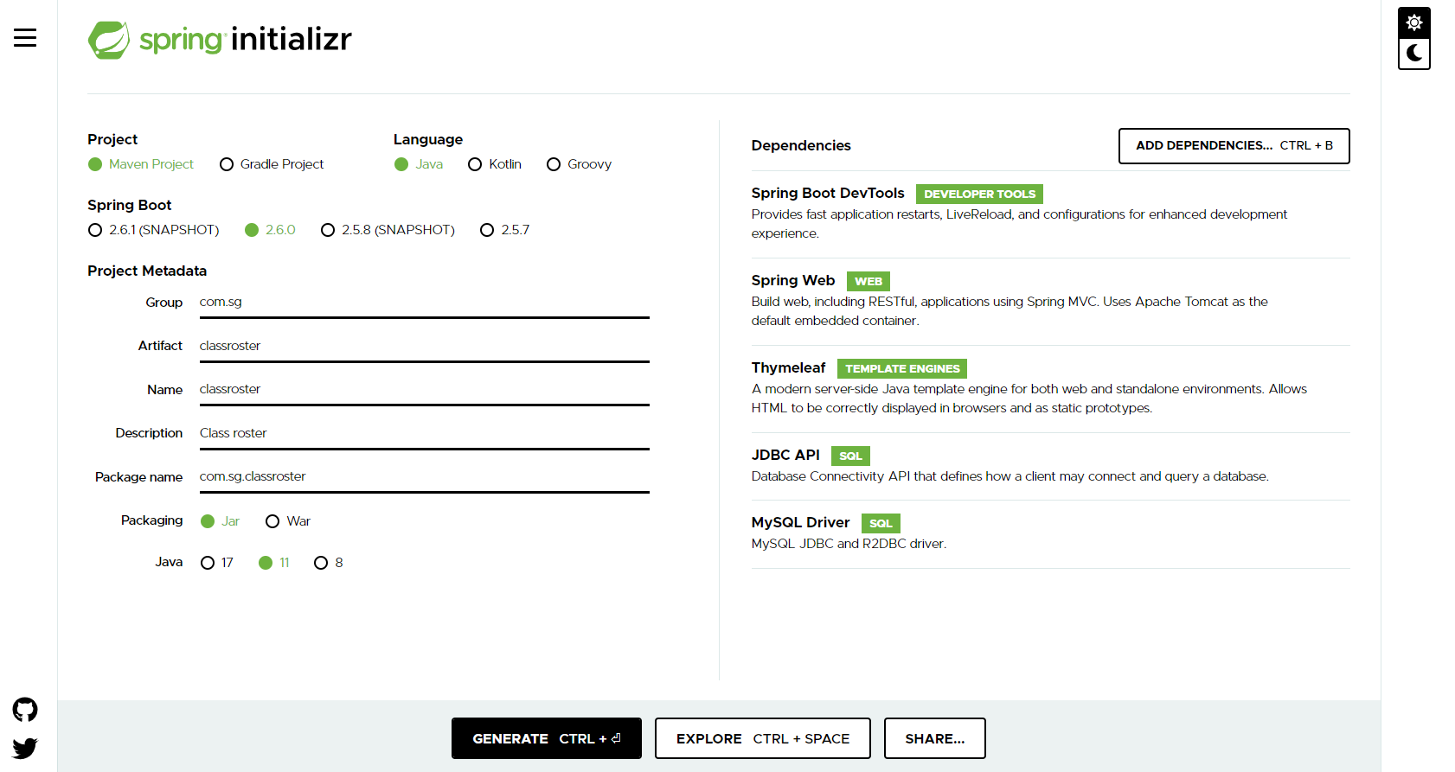

* 1. Generate to create project.
  2. This project is then downloaded in a Zip file and forms the basis of your Spring project.

## DB Component

* 1. Set up DB
     1. Run the relevant SQL scripts and **save them with relevant titles**!!!
     2. Include a few records and run a few queries to verify
  2. Set up corresponding objects
     1. These should reflect the DB tables
        1. Instance Variables & Methods
        2. Class / Static Variables and methods
  3. Set up corresponding DAO Interfaces*/Classes for b. (*Not mandatory, so if not doing it, do d & e in the relevant object class)
  4. Install the JDBCTemplate functionality into the relevant DAO classes
     1. Annotations
        1. @Repository – Above class title
        2. @AutoWired – Any variables DI-ed into the class e.g. JDBCTemplate
        3. @Transactional – Where you are updating values, especially in batches (treats the actions like a Transaction)
     2. Implement the DAO methods – CRUD operations
     3. Inner class to implement the RowMapper interface which allows for the reading of records from the DB thro’ the JDBCTemplate object

## Main Method & Controller Class

* 1. Main method class - @SpringBootApplication – Start point with main() method.
     1. ContextApplication object
  2. Controller class - @Controller – Essentially the controller of a webpage. Set this up.
  3. Put correct annotations over relevant methods with ID tags where relevant.
     1. @RequestMapping – Start point or Index page
     2. @GetMapping – Getting values
     3. @PostMapping – Posting values to the website

## HTML Pages

* 1. Set up your HTML files in resources/templates folder.
  2. Insert relevant ThymeLeaf functionality.

## Running of page

* 1. To run this … (where test is name of html file) <http://localhost:8080/test>
  2. Be aware that there is “Preview” capability in Intellij which only gives a preview, NOT a full implementation of the functionality

